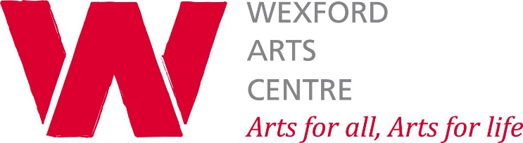

Child Safeguarding Statement

- Name of service being provided

Delivery of vibrant arts programme for all in the community
___________________________________________________________________
- Nature of Service and principles to safeguard children from harm
Wexford Arts Centre is a creative space for artists, performers, visual art facilitators and participants and audiences. We provide child-centred activities such as performances, workshops and winter/Easter/summer camps for children and young people
of all ages and all abilities. We are committed to a child led approach to our work with children
and young people. We undertake to provide a safe environment and experience where the
welfare of the child and young person is paramount.
Our policy declaration applies to all board members, paid staff, facilitators both in-house and
external, commissioned artists, artists on residencies, volunteers, and students on work
placement within our organisation. All of the above must sign up to and abide by the policies,
procedures and guidance encompassed by this statement declaration and our child
safeguarding policy and accompanying procedures. We want The Civic to be a safe, inviting,
open, inclusive, professional place for everyone.

- Risk Assessment.

We have carried out an assessment of any potential for harm to a child while availing of our services. Below is a list of the areas of risk identified and the list of procedures for managing these risks.

 | Risk Identified | Procedure in place to manage risk identified
1 | Risk of harm not noted by The  Wexford Arts Centre Personnel: board members,  staff members, workshop  facilitators, board of  management. | Introduce all board/staff to the Wexford Arts Centre Child Safeguarding Policy; roles, reporting procedures and codes of behaviour. Provision of child safeguarding training provided by Wexford Arts Centre as part of induction.
2 | Risk of harm not being reported  properly or in good time by The  Civic Staff  or facilitators. | Staff and facilitators are aware of the role of the  Mandated Person (Visual Art Manager/Administration Manager), and receive  training in child safeguarding concerns and levels of concern for reporting.
3 | Risk of young person being  harmed by The Civic staff or  facilitators. | Safe recruitment procedures involve: Taking all  reasonable steps to eliminate people who are not  suitable for working with children; and insisting all staff working with children are Garda vetted. Provide training on our child  safeguarding policy. All staff/facilitators to read and comply with Child Safeguarding policy and procedures. Children and young people never to be left alone with an adult in the building, two adult policy in place when children are in the building.
4 | Risk of harm due to bullying of a young person | Our policy outlines what constitutes bullying and  harassment, who to make a complaint to and what action the company will take in dealing with an offence of this nature.
5 | Risk of harm due to inadequate  supervision of young people | Always having two adults present during events. 12+ children will be supervised by an increased ratio of adults. Parents/guardians must always drop/collect their children inside the building
6 | Risk of harm due to inappropriate  relationship/ communications  between adult staff members and facilitators and a young person. | Adults will never be alone with a child either in the building or to give a lift to a child in a car.
7 | Risk of harm due to  inappropriate use of images of young people. | Images of any child or young person participating in activities organised by Wexford Arts Centre will not be used for any reason without the consent of the parent/caregiver.
8 | Risk of harm due to inappropriate use of young people’s personal  data. | No data is disclosed to any third party and remains confidential

- Procedures

Our Child Safeguarding Statement has been development in line with requirements under the Children First Act 2015, the Children First: National Guidance, and Tusla’s Child Safeguarding: A Guide for Policy, Procedure and Practice. In addition to the procedures listed in our risk assessment, the following procedures support our intention to safeguard children while they are availing of our service:

- Procedure for the management of allegations of abuse or misconduct against workers/volunteers of a child availing of our service.
- Procedure for the safe recruitment and selection of workers and volunteers to work with children.
- Procedure for provision of and access to child safeguarding training and information, including the identification of the occurrence of harm.
- Procedure for the reporting of child protection or welfare concerns to Tusla.
- Procedure for maintaining a list of the persons (if any) in the relevant service who are mandated persons.
- Procedure for appointing a relevant person.
All procedures listed are available upon request.

- Implementation
We recognise that implementation is an ongoing process. Our service is committed to the implementation of this Child Safeguarding Statement and the procedures that support our intention to keep children safe from harm while availing of our service. This Child Safeguarding Statement will be reviewed on 1st November, 2019, or as soon as practicable after there has been a material change in any matter to which the statement refers.

Signed ___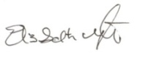________________________________
Executive Director/CEO Wexford Arts Centre

Elizabeth Whyte
Executive Director/CEO
Wexford Arts Centre
Cornmarket
Wexford
elizabeth@wexfordartscentre.ie
Tel: 053 9123764 x 5

For queries, please contact: Catherine Bowe/Giovanna Delaney
catherine@wexfordartscentre.ie or Giovanna@wexfordartscentre.ie
Tel: 053 9123764 x 3 Catherine or x 2 for Giovanna.
Relevant Person/s under the Children First Act 2015

